Making Oobleck

Subject:  Related Subjects: | Grade Level(s): 4 & 5  Length of Lesson: 98 minutes | Type: Project  Keywords: Density, Fluids, Viscosity

Lesson Overview
The student will learn about non-Newtonian fluids

Lesson Focus
In this experiment students will create a substance called a non-newtonian fluid (oobleck) which is comprised of cornstarch and water. A non-newtonian fluid can either thicken or thin under shear stress, oobleck will thicken.

Lesson Objective(s) | By the end of this lesson, students will…  - Learn the concepts of attraction, repulsion, friction, polarity, and charge.

Lesson Timing

5 minutes | Introduce the Lesson
30 minutes | ...

Materials | - 35 Styrofoam Bowls  - 4 16 oz Argo Corn Starch  - 35 Plastic Zip Lock Bags  - Red, Blue, and Yellow Food Paste.  - 20 Spoons
Instructor Prep | - Step 1
Related Resources | - List related lessons/ppts etc available from USC or outside, trusted orgs

Lesson Plan

Introduction
Introduce students to the learning goals and make connections to past and present learning experiences. Stimulate interest and prompt students to identify their own questions about the topic. This can link the lesson to real world examples, introduce associated STEM careers, and assess their prior knowledge on the topic.

- Step 1

Procedure
List the steps of the activity. Remember to focus on leading students to the solution, rather than just telling them what to do. Include pictures of steps if you have them. Be sure to include some steps for discussion and reflection.

- Step 1

Wrap-up
End the lesson with some final discussions about what students designed/discovered. Connect their activity back to the focus question/problem, real world examples, and STEM careers.

Also include notes about any special cleanup considerations

Lesson Background for Teachers

Suggested Real-World STEM Connections

Role Model in STEM

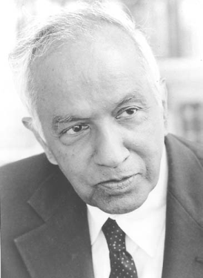
Name: Subrahmanyan Chandrasekhar
Years: 1910-1995
Quick Facts
- Discovered the Chandrasekhar limit, which is the limit of how massive white dwarf stars can be
- Awarded Nobel Prize in Physics in 1983
- Was awarded FRS by Royal Society
- Made a countless amount of significant contributions to astrophysics, including stellar structure and dynamical friction

Source(s):
- https://en.wikipedia.org/wiki/Subrahmanyan_Chandrasekhar

Lesson Variations and Options
Include descriptions of alternative methods or ways to present things.

Explanation
Describe the background concepts and explanations behind the lesson. This can be more in depth than a teacher/instructor would actually share with students.

Key Concepts and Vocabulary
- Word 1: Grade Appropriate Definition
- Word 2: Grade Appropriate Definition

Safety Notes
- Safety instruction

